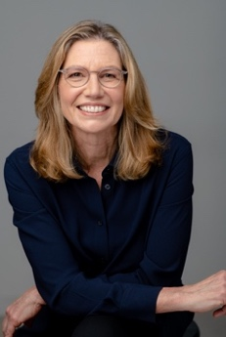

|  |  |
| --- | --- |
| **Company:** | SLS Coaching & Consulting LLC  *Transforming results through individual, team and group coaching*  The firm was established in 1999 to assist organizations in building strong resilient leaders to better achieve organizational goals. Sandi has coached executives from diverse organizations in the public, private and non-profit sectors. The coaching helps clients to build leadership confidence, to optimize their energy and motivation and to thrive in change for themselves as well as their teams and organizations. |
| **Credentials:** | * President, SLS Coaching & Consulting, LLC * MCC, Master Certified Coach with International Coaching Federation * MBA, Columbia University * Adjunct Professor, Leadership Development, Robert H. Smith School of Business, University of Maryland * Instructor, Leadership Coaching for Organizational Performance at American University * Certified Analyst & Licensed Distributor, Target Training International, DISC, 12 Driving Forces, Leadership Circle Profile™, NEO * Author: Building the Core Competencies of Change: A Guide to Coaching in Organizations, 2021 and Building an Organizational Coaching Culture, Chapters 10 & 11, 2024 |
| **Business Experience:** | * Organizational Management Consultant in private and non-profit sectors * Manager at Johnson & Johnson, Hearst/ABC and Ferrero N.A. specializing in marketing and strategy * Executive coaching, training and team facilitation in leadership, teamwork, development, and high performance * Team facilitation for change management, communication and optimizing team performance |
| Education: | M.B.A., Columbia University, NY, NY  B.A., Colgate University, Hamilton, NY |
| Coaching Focus: | * Senior executives and high-potential employees * Team performance |
| **Professional Affiliations:** | * International Coaching Federation (ICF) * Board Member, ICF Independent Review Board * Columbia University & Colgate University alumni organizations * Target Training International * Leadership Circle Profile |
| **Number:** | 202-550-4000 |
| **Email:** | [sstewart@slscoach.com](mailto:sstewart@slscoach.com)  [www.sandraLstewart.com](http://www.sandraLstewart.com) |
| **Base Location:** | Washington, D.C. |



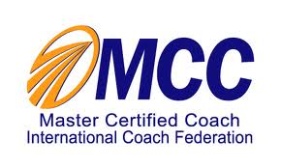

Sandra (Sandi) Stewart, MBA, MCC

**Speaking Engagements and Webinars**

**Health and Human Services coaching cohort**

*What Makes Coaching Deep*, Virtual

**HR World Congress 2023**

Masterclass: *The Value of Coaching In Organizations*, Virtual Webinar

ROBERT GARCIA, Vice President - ICF COACHING IN ORGANIZATIONS

SANDRA L. STEWART, Executive Coach | Coaching Instructor Consultant

**New York University and ICF NY**

*Navigating the Grey: How to Integrate Consulting into Your Coaching Practice*, In-Person

**Coach to Transformation**

*Designing Coaching Engagements*,India, Virtual

**Health and Human Services coaching cohort**

*Coaching with Emotions: Helping Your Clients Thrive in Change*, Virtual

**SAP global internal coaches cohort**

*Coaching with Emotions and Values*, Virtual

**Human Capital Institute**

*Catalyzing Organizational Strategy Through Integrating Coaching Skills in Leaders*, *Teams and Culture*, Virtual

**ITRC LEAD at the Faculty for Organizational Studies in Slovenia**

*How is leadership different after Covid?, Slovenia, Virtual*